AFS PIEDMONT CHAPTER MEETING REGISTRATION
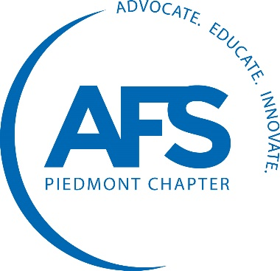
January 16-17, 2019
Pineville, NC
Hilton Garden Inn Pineville
425 Towne Centre Boulevard, Pineville, NC 28134
Rate $149/Night standard 1 king or 2 queen room
Call for reservations: (704) 889-3279
Group Code: AFSPC
Or reserve online: http://bit.ly/Jan2019Hotel

If this link does not work, copy and paste it into your internet browser.
**MUST BOOK BY January 2, 2019**

Meeting Topic: Casting Defects

Wednesday, January 16

7:30 – 8:30 am Meeting Registration at the hotel

8:30 – 9:20 am Temperature Defects, George Frigm, Electronite

9:20 – 10:10 am Iron Defects, Marc King, FerroGlobe

10:10 – 10:30 am BREAK

10:30 – 11:15 am Non-Ferrous Defects, Mike Buyarski, Federal Metals

11:15 – 12:00 pm Slag Defects, Dave Williams, ASI International

12:00 – 1:30 pm Lunch on your own

1:30 – 2:15 pm Green Sand Defects, Donald McLain, American Colloid

2:15 – 3:00 pm Core Defects, Stan Forehand, HA International

3:00 – 5:00 pm AFS Piedmont Board Meeting, followed by
AFS 2019 Southeast Regional Planning Meeting

6:00 – 7:00 pm Social Hour at the Hotel

7:00 – 9:00 pm Dinner at the Hotel

Casting Defect Examples
As an added bonus for meeting attendees our panel of experts have agreed to help evaluate any actual samples or photos of casting defects you would like to provide. Also, if you have found a solution to your casting defect and would like to share with the group, then that would be great.

Please contact Bill Yost at bill.yost@conbraco.com to submit your samples or examples.

Thursday, January 17
9:00 am PLANT TOUR
Conbraco Industries-Pageland Pants and Closed Toed Shoes are required.
1509 South Van Lingle Mungo Blvd. (Does not have to be steel toed shoes)
Pageland, South Carolina, 28079 Other PPE will be provided.
Parking available on site.

AFS PIEDMONT CHAPTER MEETING REGISTRATION
January 16-17, 2019
Pineville, NC

PLEASE PRE-REGISTER by January 9, 2019

Name_______________________________ Company______________________________

Meeting Registration $125.00 x ____ = ______

Late Registration Fee after 1/9/19 $10.00 x ____ = ______

TOTAL = ______

Attending Dinner? Y N

Attending Tour? Y N

Online Registration: http://afspiedmont.org/meeting-registration

Have questions, contact Haley Hollifield, (843)784‐2251 or haley@carolinametalcastings.com

Make checks payable to: AFS Piedmont Chapter
Mail registration form and payment to: Haley Hollifield
Carolina Metal Castings
PO Box 95
Hardeeville SC 29927

Please plan to join us in Pineville and Pageland for a great meeting and tour!
