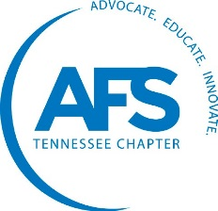
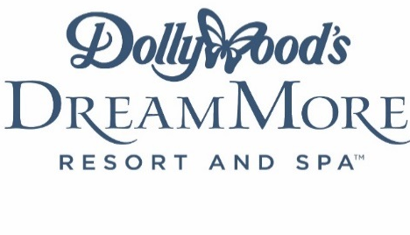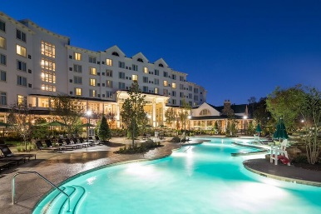
84th AFS Southeast Regional Conference
March 22-24, 2017 Dollywood’s DreamMore Resort Pigeon Forge, TN

Dear AFS Members, Corporate Members and Foundry Suppliers,

The Tennessee Chapter of the American Foundry Society is pleased to invite you to the 84th Annual Southeast Regional Conference. The year’s conference will be held in the Great Smoky Mountains of Tennessee. Dollywood’s DreamMore Resort will be hosting the Event along with a Golf outing at the Gatlinburg Golf Course March 22 – 24, 2017. We hope to have you and your company come join us to make this Regional Conference a success and enjoy everything the Pigeon Forge and Gatlinburg areas have to offer!
We will be offering several Sponsorship opportunities allowing your company to show your support of our industry and also a chance to highlight your company’s products, expertise, skills and personnel. We hope you will consider these sponsorship offerings.
We have enclosed a form for advertising in the Official Southeast Regional Program which all attendees will receive. This Program will also be available before and during the Conference for viewing on line at www.afs-tn.org. The available sizes, locations and costs are noted on the form. Along with your order, please provide your Company’s logo as a high resolution PDF or EPS. Your add order and artwork will be needed by February 17, 2017 to be sure we make the printing deadline.
There is also an opportunity to be a Hospitality Sponsor, which will include a 10% discount when combined with a Program Booklet Ad. Your Company Name or Logo will be on display with a PowerPoint Presentation during both Evenings Hospitality Events along with a display at the golf outing Wednesday afternoon. You will also receive 10 drink tickets for each evening’s event along with 10 drink tickets for the golf outing to share with others.
In addition to the above, we have a limited number of Table Top Displays available across the hall from the Conference. Open to Foundries and Suppliers, we will have 15 tables available at $250.00 to showcase your products, services and expertise. We encourage you to take advantage of this limited opportunity and sign up quickly as past history has shown this to be quite popular.
Thank you again for your support of the Southeast Regional, the American Foundry Society and our Industry. The Tennessee Chapter of AFS looks forward to seeing you at the Southeast Regional in the Great Smoky Mountains this spring.

Best Regards,
AFS Southeast Regional Committee

