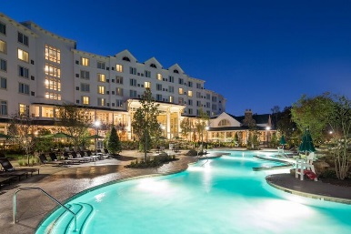
84th AFS Southeast Regional Conference
March 22-24, 2017 Dollywood’s DreamMore Resort Pigeon Forge, TN
Resort Registration – AFS Southeast Regional Conference
The DreamMore Resort, 2525 DreamMore Way, Pigeon Forge, TN 37863
Phone (800) 365-5996. Be sure to mention the AFS Southeast Regional Conference to receive the group rate of $152.00. The room rate will be honored 3/19/17 through 3/25/17. Room Block rate available until 2/21/17.

Wednesday – March 22nd
11:00 AM - Golf and Lunch; Gatlinburg Golf Course, Pigeon Forge, TN
5:30 PM – 7:30 PM – Evening Hospitality Event for all Registered Attendees and
Spouse/Guest @ Dollywood DreamMore Resort Patio.

Thursday – March 23rd
7:00 AM – 10:00 AM – Buffet Breakfast @ Song and Hearth
7:45 AM – 4:00 PM – Table Top Displays
8:05 AM – 11:50 AM – Conference Technical Sessions
12:00PM – 1:00 PM – Dixieland Picnic @ Song and Hearth
1:05 PM – 4:30 PM – Conference Technical Sessions
5:30 PM – 7:30 PM – Evening Hospitality Event for all Registered Attendees and
Spouse/Guest @ Dollywood DreamMore Resort Patio.

Friday – March 24th
8:00 AM – 12:00 PM – Local Tour – TBA

Southeast Regional Registration Information
Session Attendee Name(s): ____________________________ E-Mail:___________________
Company: ________________________________________ Phone: ____________________
Spouse/Guest Name: _______________________________ (not attending Technical Sessions)
General Session Registration $275.00 x _______ = ________ Presenter – check here _____
Late (after 2/21) Registration $325.00 x _______ = ________
Spouse/Guest Registration $130.00 x _______ = ________
Golf Registration with Lunch $90.00 x _______ = ________
Golf Requested Pairings with _________________________________________________

Please mail Registration Form and Check made payable to “AFS Tennessee Chapter” to:
Karen Dunegan (dune4of5@aol.com) at Eureka Foundry, PO Box 6039, Chattanooga, TN 37401
By 2/17/17. THANK YOU for supporting the AFS Southeast Regional.

